
- Code: N352-1L012FLAM
Upper : Leather Lining : Leather Sole : PU (Polyurethane) Accessories : Buckle Heel Type : ANATOMIC

RUBIK - L012Beige

Upper - Leather
Lining -Leather
Midsole - PU(polyurethane)
Sole - PU(polyurethane)
Accessories - Buckle
Heel Type - Flat Anatomic

Upper - Leather
Lining -Leather
Midsole - PU(polyurethane)
Sole - PU(polyurethane)
Accessories - Buckle
Heel Type - Flat Anatomic

Upper - Leather
Lining -Leather
Midsole - PU(polyurethane)
Sole - PU(polyurethane)
Accessories - Buckle
Heel Type - Flat Anatomic
Upper : Leather Lining : Leather Sole : PU (Polyurethane) Accessories : Buckle Heel Type : ANATOMIC
RUBIK- ORCHIDE
- Code: N352-1L012ORCH
Upper : Leather Lining : Leather Sole : PU (Polyurethane) Accessories : Buckle Heel Type : ANATOMIC
RUBIK-YELLOW

Upper - Leather
Lining -Leather
Midsole - PU(polyurethane)
Sole - PU(polyurethane)
Accessories - Buckle
Heel Type - Flat Anatomic

Upper - Leather
Lining -Leather
Midsole - PU(polyurethane)
Sole - PU(polyurethane)
Accessories - Buckle
Heel Type - Flat Anatomic
Upper : Leather Lining : Leather Sole : PU (Polyurethane) Accessories : Buckle Heel Type : ANATOMIC

Upper - Leather
Lining -Leather
Midsole - PU(polyurethane)
Sole - PU(polyurethane)
Accessories - Buckle
Heel Type - Flat Anatomic
RUBIK- BLUE
- Code: N352-1L012BLUE
Upper : Leather Lining : Leather Sole : PU (Polyurethane) Accessories : Buckle Heel Type : ANATOMIC
RUBIK-GREEN
RUBIK-DARK RED
RUBIK - L012Pastel Pink

Upper - Leather
Lining -Leather
Midsole - PU(polyurethane)
Sole - PU(polyurethane)
Accessories - Buckle
Heel Type - Flat Anatomic
Upper : Leather Lining : Leather Sole : PU (Polyurethane) Accessories : Buckle Heel Type : ANATOMIC
RUBIK - L012Purple

Upper - Leather
Lining -Leather
Midsole - PU(polyurethane)
Sole - PU(polyurethane)
Accessories - Buckle
Heel Type - Flat Anatomic
Upper : Leather Lining : Leather Sole : PU (Polyurethane) Accessories : Buckle Heel Type : ANATOMIC

Upper - Leather
Lining -Leather
Midsole - PU(polyurethane)
Sole - PU(polyurethane)
Accessories - Buckle
Heel Type - Flat Anatomic
RUBIK-TURQOISE
ZOE-FLAME
RUBIK - L012Turqoise

Upper - Leather
Lining -Leather
Midsole - PU(polyurethane)
Sole - PU(polyurethane)
Accessories - Buckle
Heel Type - Flat Anatomic
RUBIK - L012White

Upper - Leather
Lining -Leather
Midsole - PU(polyurethane)
Sole - PU(polyurethane)
Accessories - Buckle
Heel Type - Flat Anatomic
ZOE - 1L011

ZOE-BLUE

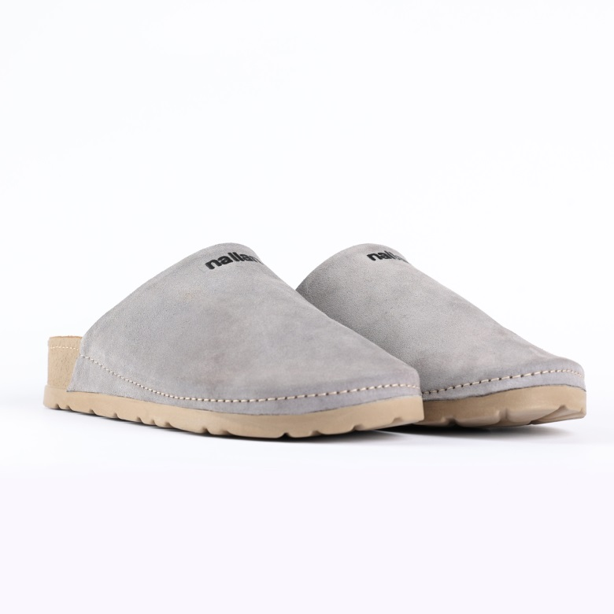
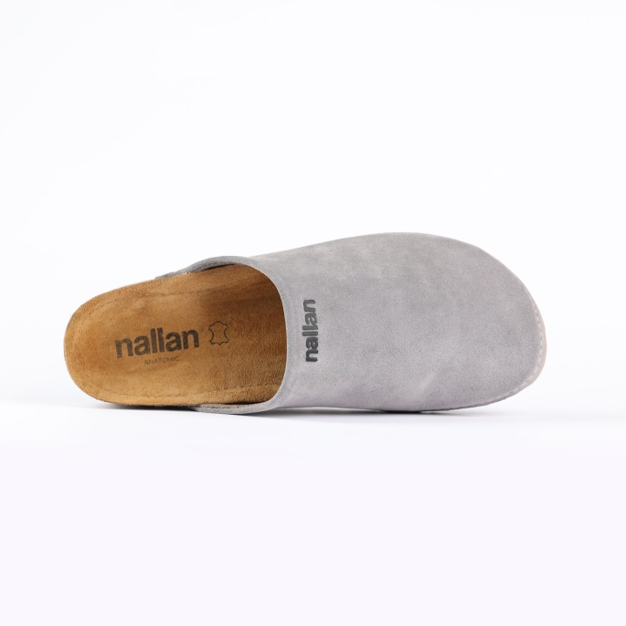
SLIPPERS – NUMA- GRAY

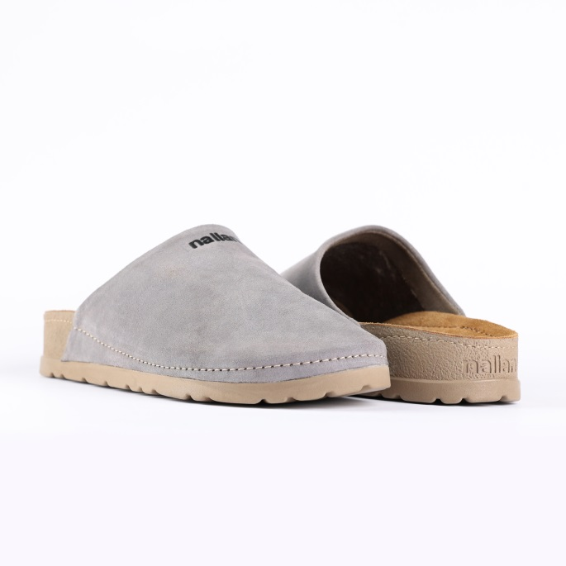

Code: N455-1V076GRAY
Upper : Velour
Lining : Leather Sole : PU (Polyurethane) Heel Type : Anatomic

SIZE: 36-42 41-46

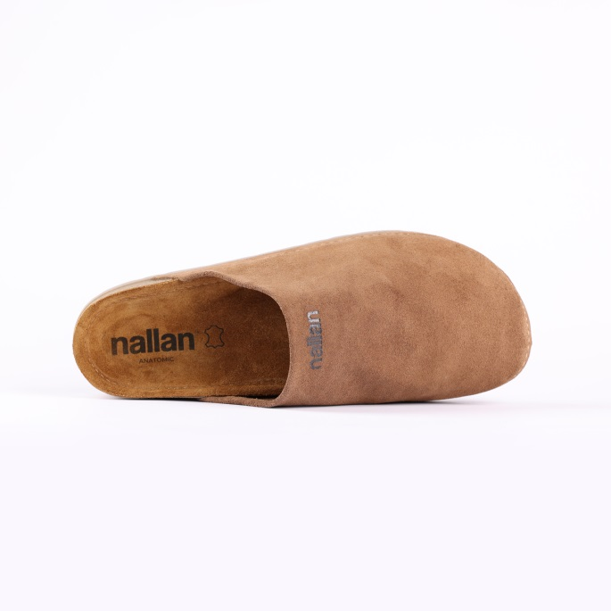
SLIPPERS – NUMA- CHESTNUT

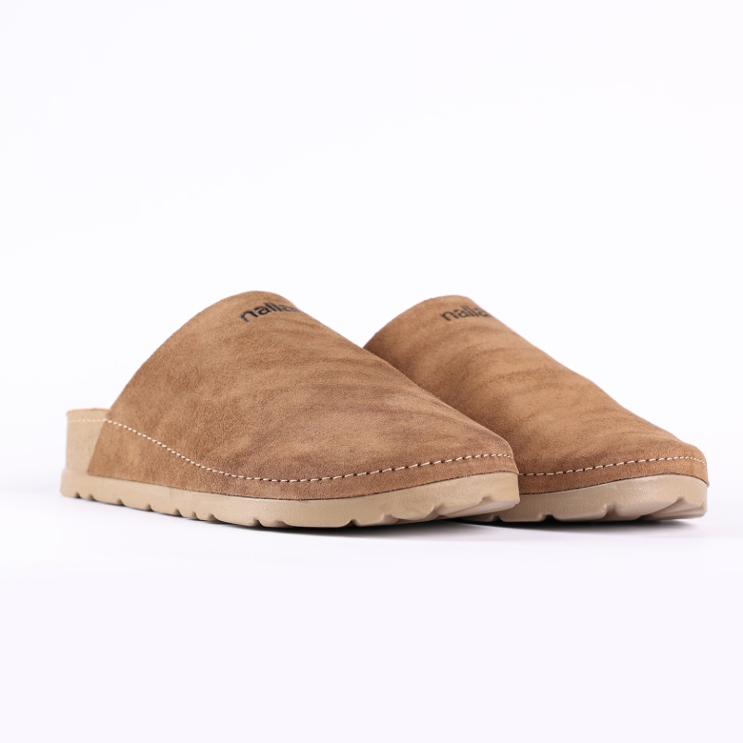

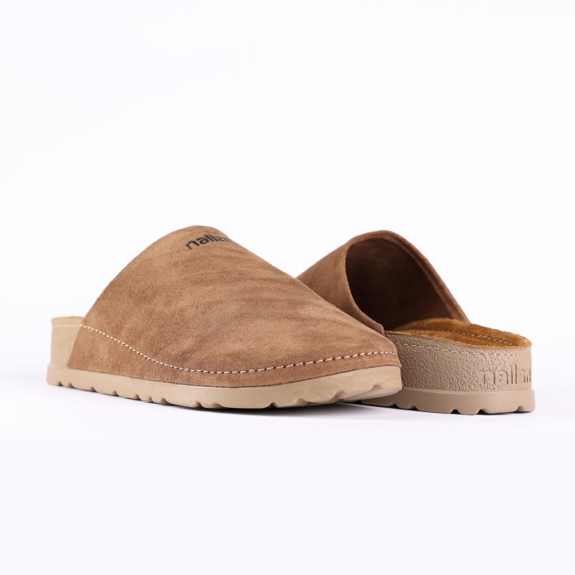

Code: N455-1V076CHES
Upper : Velour
Lining : Leather Sole : PU (Polyurethane) Heel Type : Anatomic

SIZE: 36-42 41-46

SIZE:37-42

SLIPPERS – NUMA- BLAND

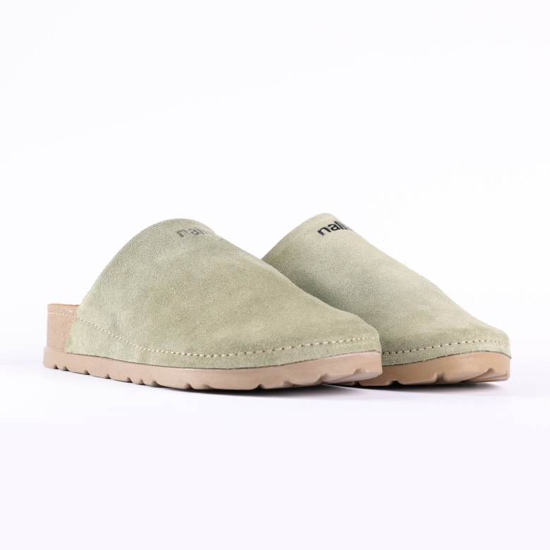
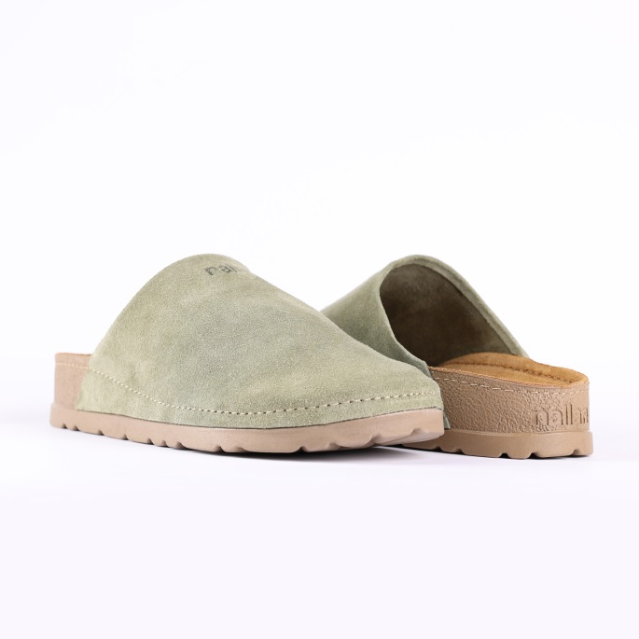

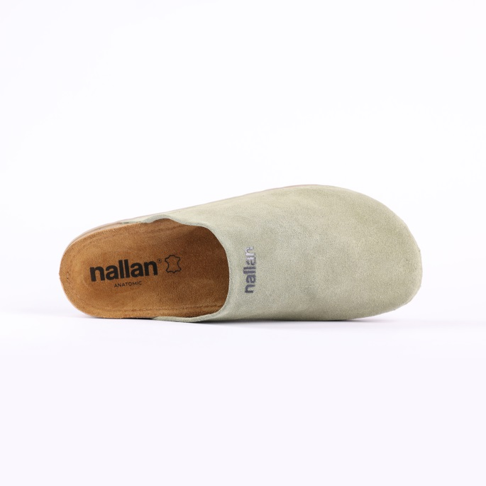

Code: N455-1V076BLAN
Upper : Velour
Lining : Leather Sole : PU (Polyurethane) Heel Type : Anatomic

SIZE: 36-42 41-46

SLIPPERS – NUMA- YALE

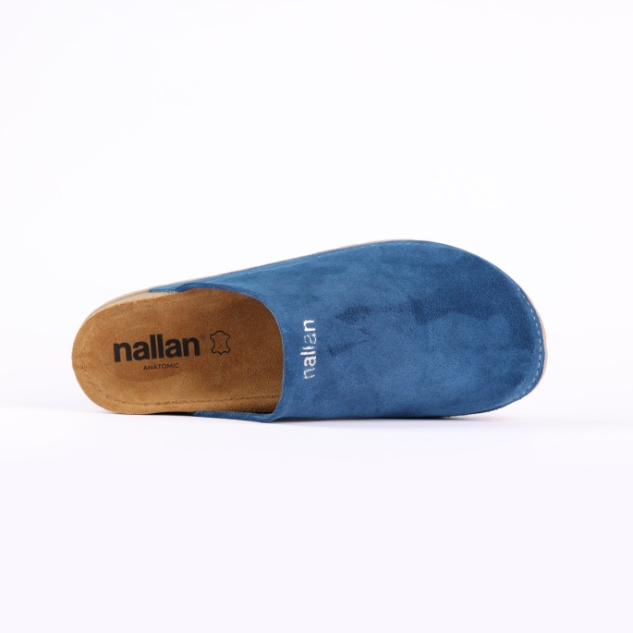
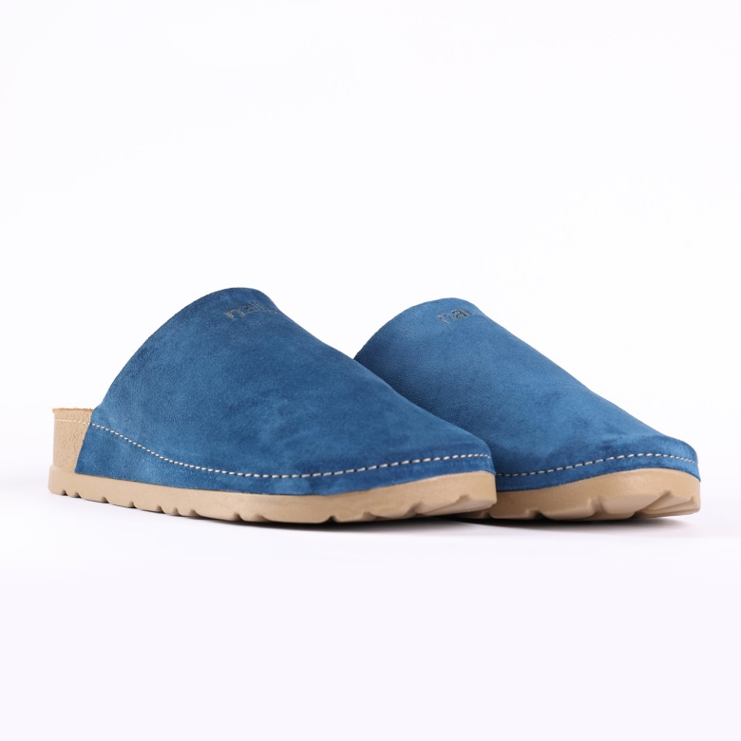

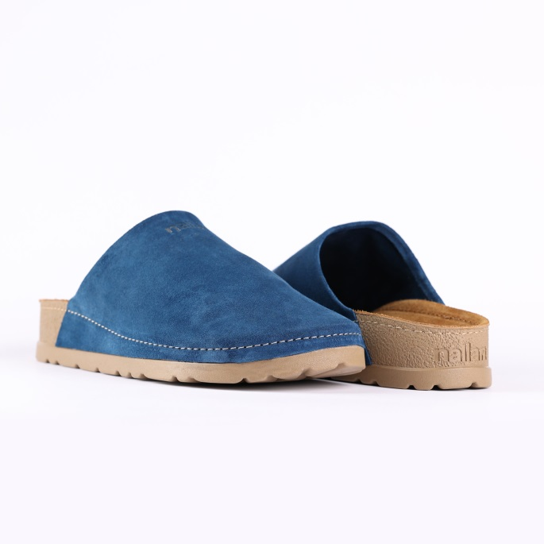

Code: N455-1V076YALE
Upper : Velour
Lining : Leather Sole : PU (Polyurethane) Heel Type : Anatomic

SIZE: 36-42 41-46

SLIPPERS – NUMA- STONE

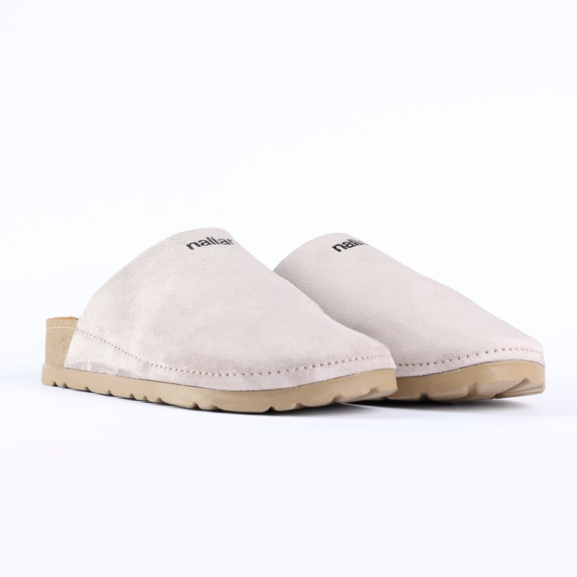

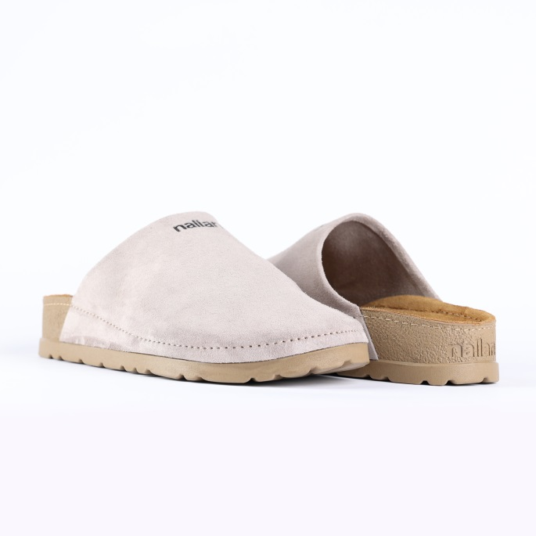
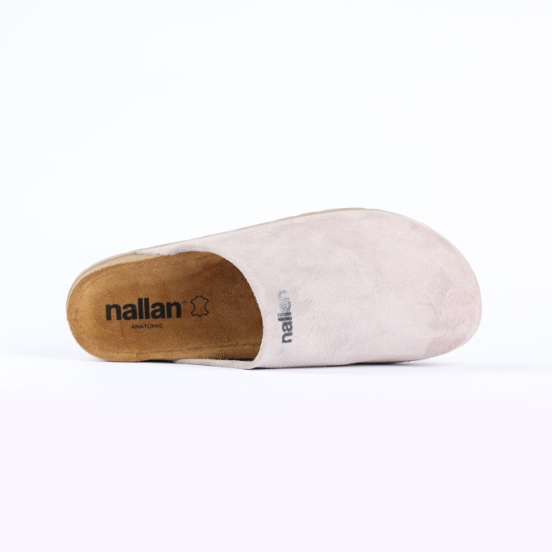

Code: N455-1V076STON
Upper : Velour
Lining : Leather Sole : PU (Polyurethane) Heel Type : Anatomic

SIZE: 36-42 41-46

SLIPPERS – NEXA- CLOVE

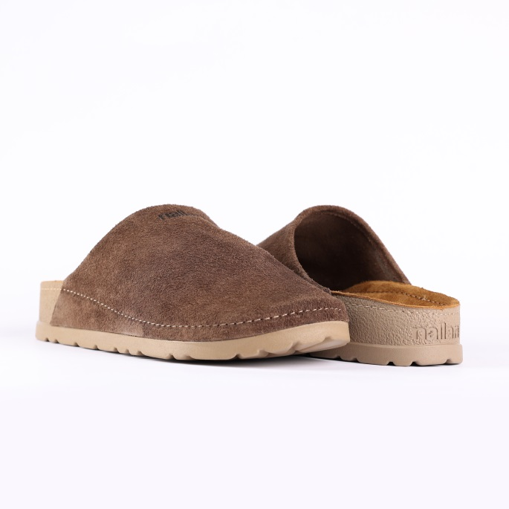
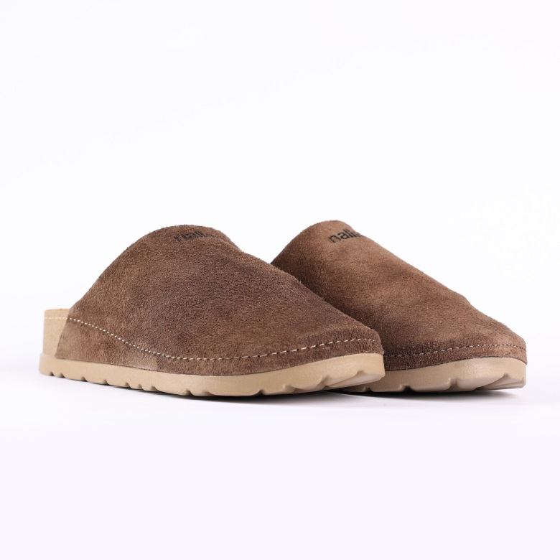

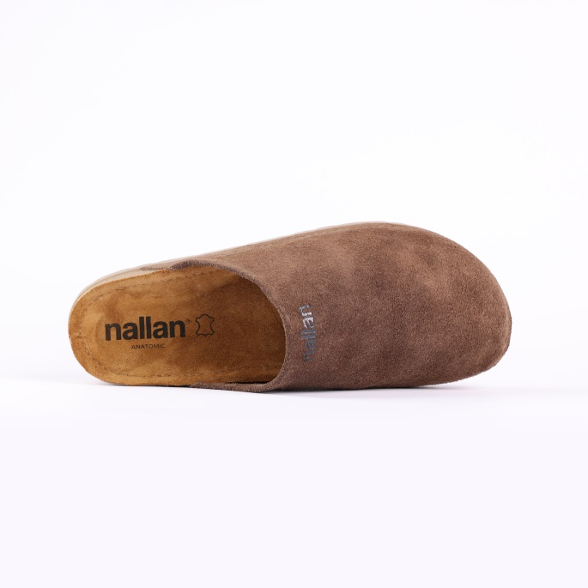
Code: N455-1V076CLOV
Upper : Velour
Lining : Leather Sole : PU (Polyurethane) Heel Type : Anatomic

SIZE: 36-42 41-46

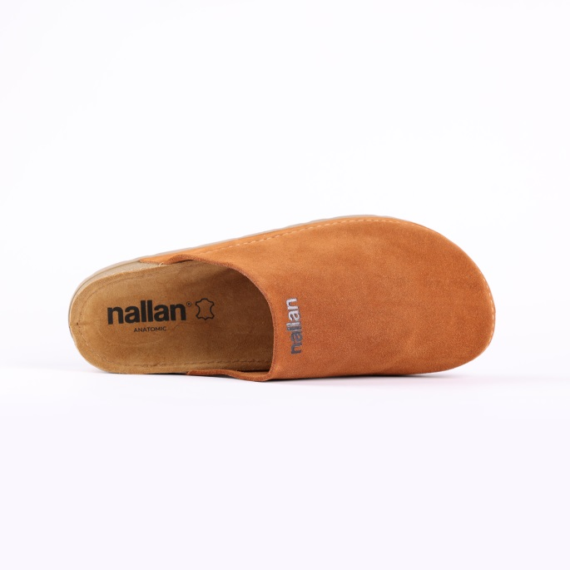
SLIPPERS –NUMA- CARAMEL

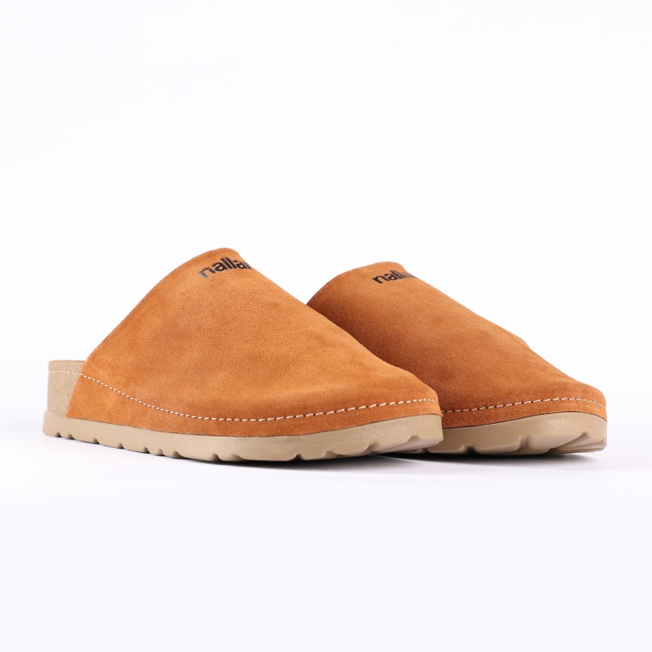

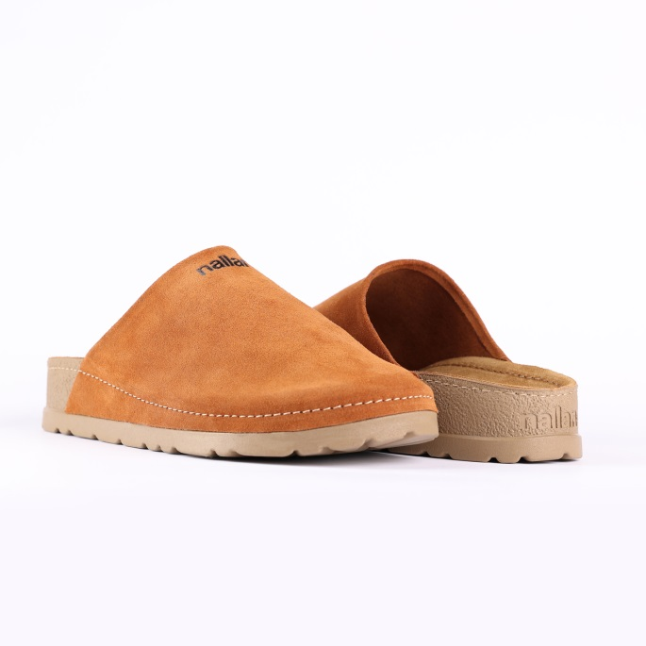

Code: N455-1V076CARM
Upper : Velour
Lining : Leather Sole : PU (Polyurethane) Heel Type : Anatomic

SIZE: 36-42 41-46

SLIPPERS – NUMA- DEMITASSE

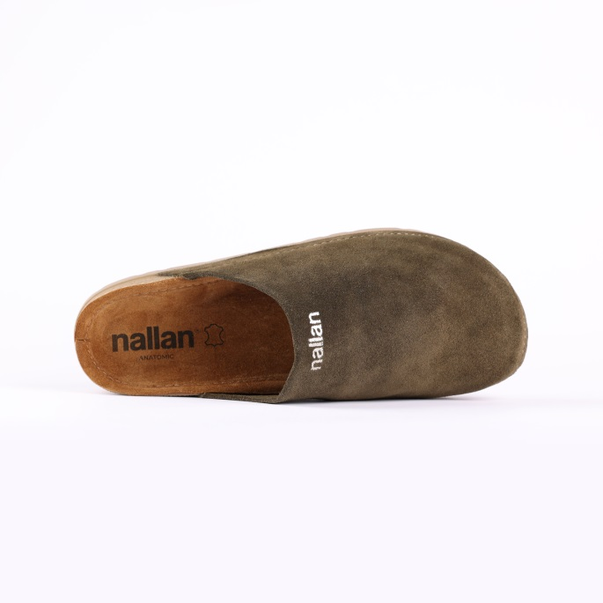
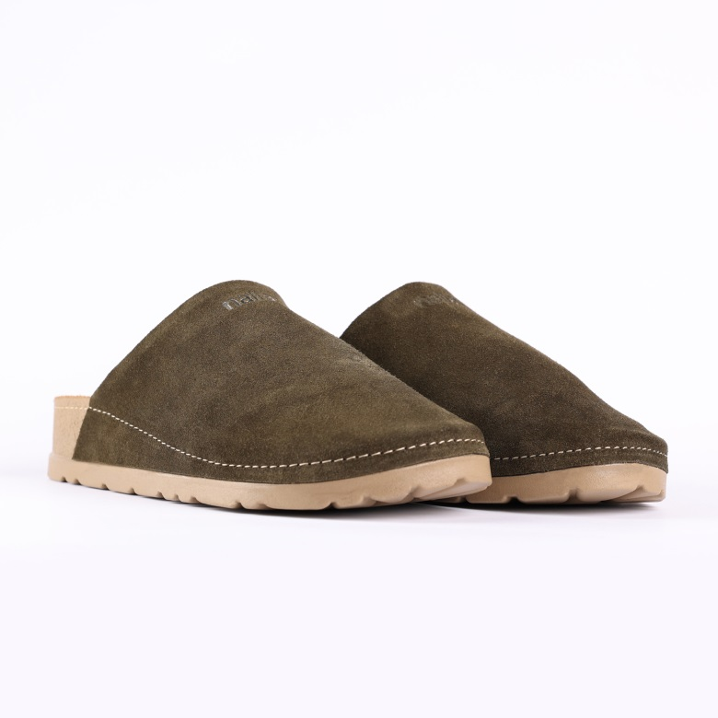
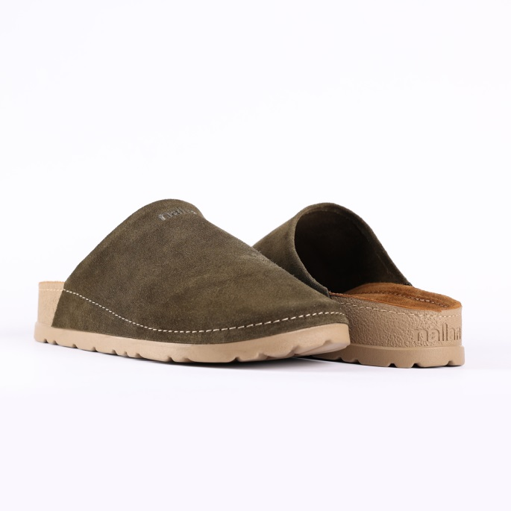

Code: N455-1V076DEMI
Upper : Velour
Lining : Leather Sole : PU (Polyurethane) Heel Type : Anatomic

SIZE: 36-42 41-46

SLIPPERS – NUMA- LIGHT GRAY

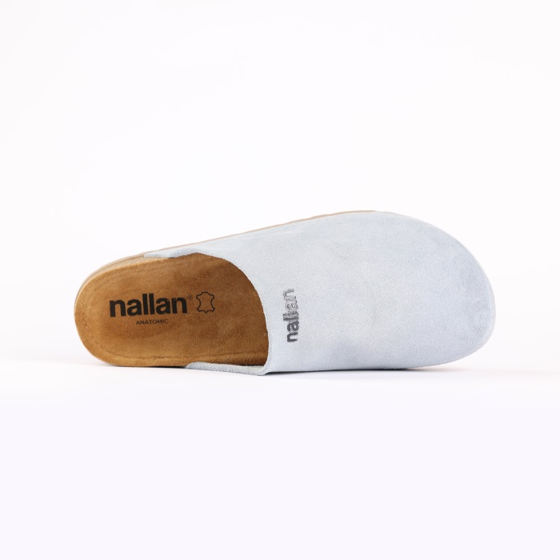
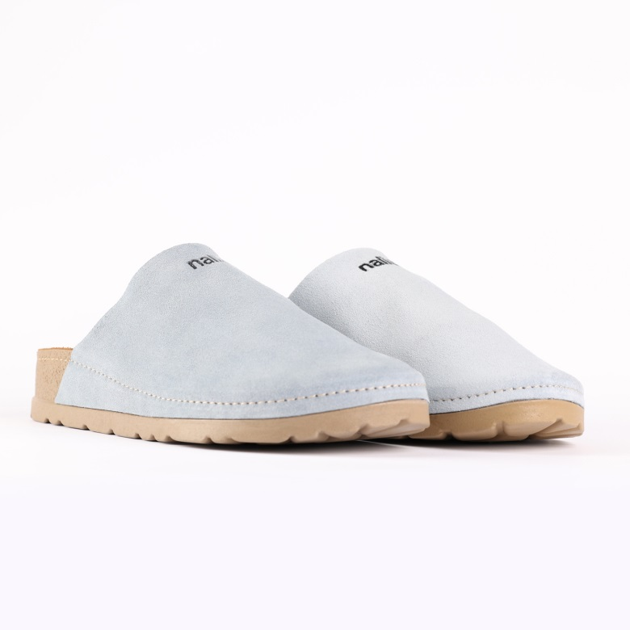
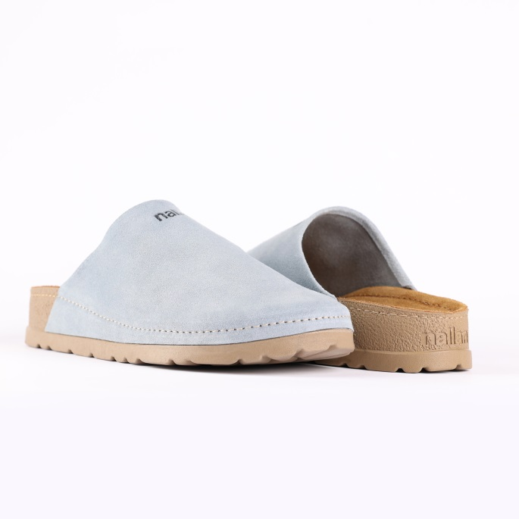

- Code: N455-1V076LGRY
Upper : Velour
Lining : Leather Sole : PU (Polyurethane) Heel Type : Anatomic

SIZE: 36-42 41-46

SIZE:37-42

SIZE: 37-42

SIZE: 37-42

Upper - Leather
Lining -Leather
Midsole - PU(polyurethane)
Sole - PU(polyurethane)
Accessories - Buckle
Heel Type - Flat Anatomic

Upper - Leather
Lining -Leather
Midsole - PU(polyurethane)
Sole - PU(polyurethane)
Accessories - Buckle
Heel Type - Flat Anatomic

Upper - Leather
Lining -Leather
Midsole - PU(polyurethane)
Sole - PU(polyurethane)
Accessories - Buckle
Heel Type - Flat Anatomic

Upper - Leather
Lining -Leather
Midsole - PU(polyurethane)
Sole - PU(polyurethane)
Accessories - Buckle
Heel Type - Flat Anatomic

Upper - Leather
Lining -Leather
Midsole - PU(polyurethane)
Sole - PU(polyurethane)
Accessories - Buckle
Heel Type - Flat Anatomic

Upper - Leather
Lining -Leather
Midsole - PU(polyurethane)
Sole - PU(polyurethane)
Accessories - Buckle
Heel Type - Flat Anatomic

Upper - Leather
Lining -Leather
Midsole - PU(polyurethane)
Sole - PU(polyurethane)
Accessories - Buckle
Heel Type - Flat Anatomic

Upper - Leather
Lining -Leather
Midsole - PU(polyurethane)
Sole - PU(polyurethane)
Accessories - Buckle
Heel Type - Flat Anatomic

Upper - Leather
Lining -Leather
Midsole - PU(polyurethane)
Sole - PU(polyurethane)
Accessories - Buckle
Heel Type - Flat Anatomic

Upper - Leather
Lining -Leather
Midsole - PU(polyurethane)
Sole - PU(polyurethane)
Accessories - Buckle
Heel Type - Flat Anatomic

Upper - Leather
Lining -Leather
Midsole - PU(polyurethane)
Sole - PU(polyurethane)
Accessories - Buckle
Heel Type - Flat Anatomic

Upper - Leather
Lining -Leather
Midsole - PU(polyurethane)
Sole - PU(polyurethane)
Accessories - Buckle
Heel Type - Flat Anatomic
